Policy & object
Virtual IPS
Here select 2nd option
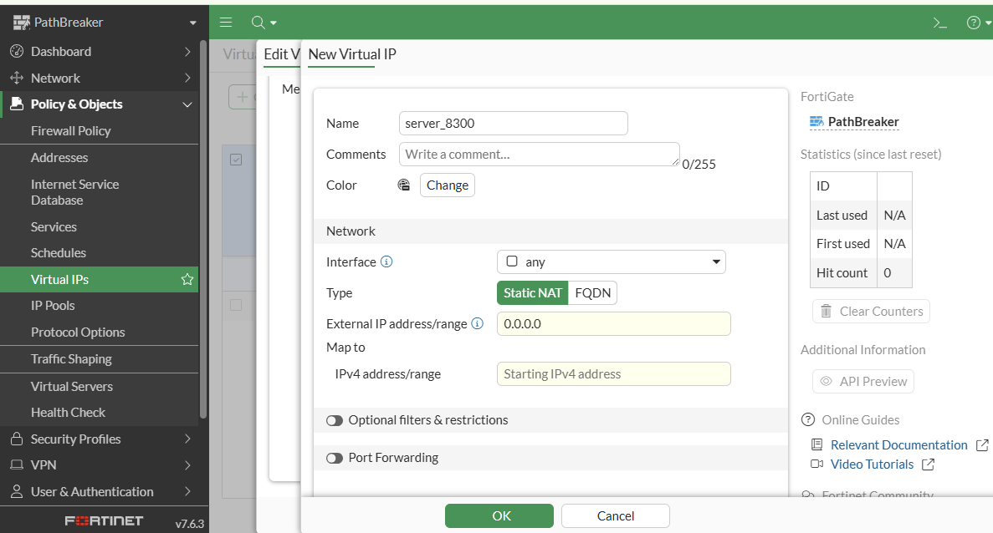

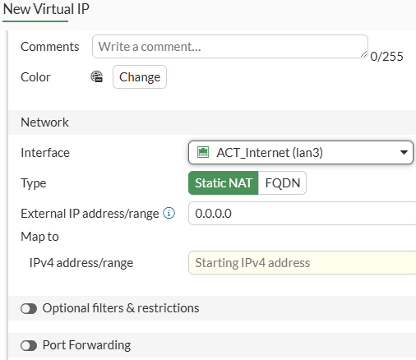

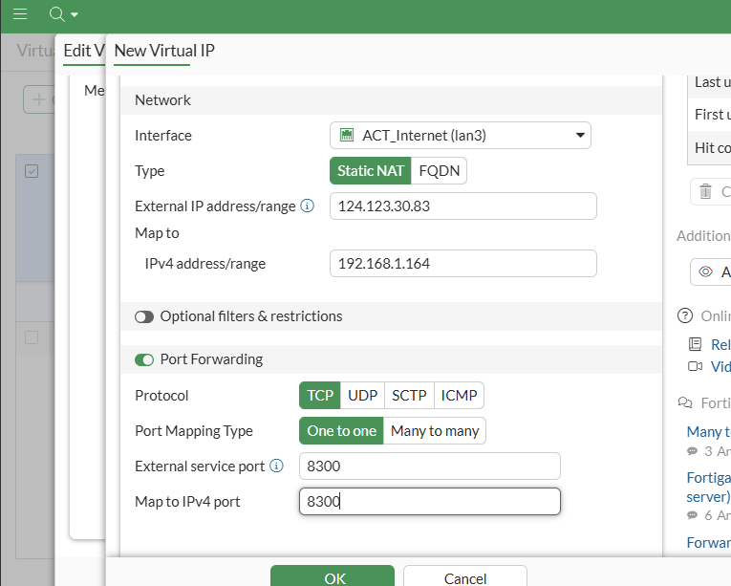

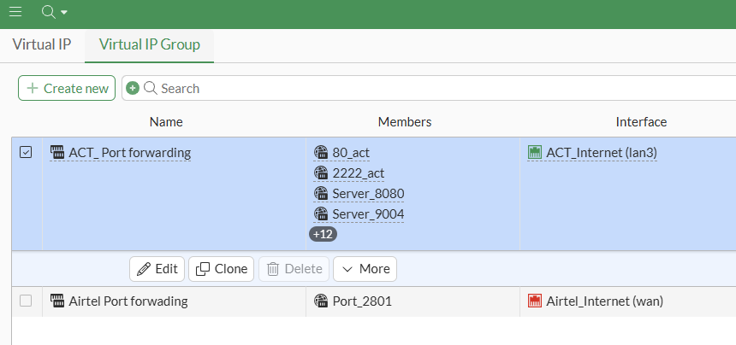

Error
This error is in side code not allowing port number
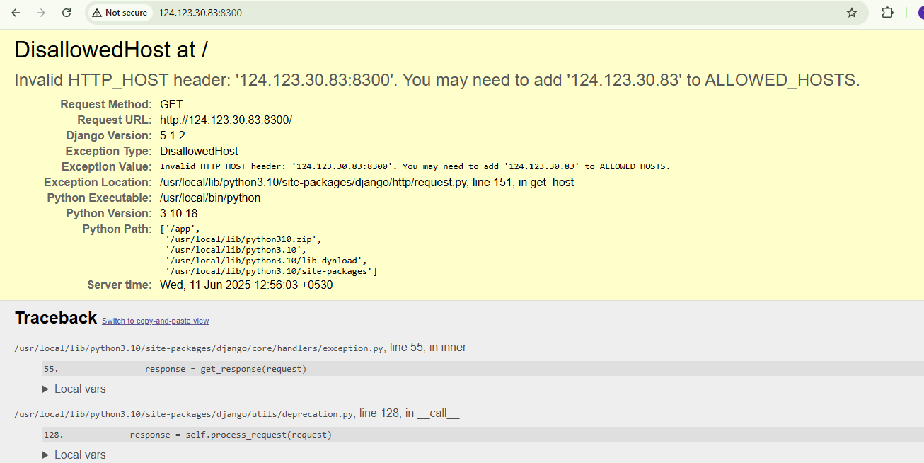

https://github.com/roboxaind/rbx_management/blob/main/roboxa_technologies/roboxa_technologies/settings.py

